In the formulas following:

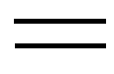 Indicates a double bond.

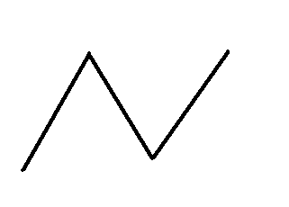 Each end or corner indicates carbons with enough hydrogens attached to all carbons to make 4 bonds for each carbon atom.

A gradually darkened bond means a structure where the head could go forward or backward and indicates more than one isomer.

 Indicates a positive charge on that atom and that it can attaché one more bond than normal.

 Indicates a negative charge on that atom and one less bond possible than normal.

Is a temporary bond.

 Indicates a backward bond.

Chemical Name: Abietic Acid
Structural Formula:
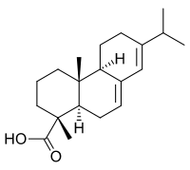
Molecular Formula: C₂₀H₃₀O₂
Molecular Weight: 302.45 g
A weak contact allergen found in pine wood and used in lacquers and soaps.

Chemical Name: Acetic acid
Structural Formula:
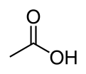
Molecular Formula: C₂H₄O₂
Molecular Weight: 60.05g
The chief acid in vinegar.

Chemical Name: Acetaminophen
Structural Formula:
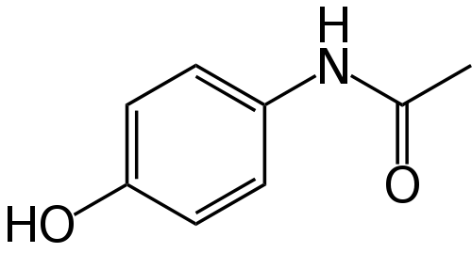
Molecular Formula: C₈H₉NO₂
Molecular Weight: 151.17 g/mol
A widely used over-the-counter analgesic (pain reliever) and antipyretic (fever reducer).

Chemical Name: Acetylcholine
Structural Formula:
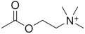
Molecular Formula: C₇NH₁₆O+
Molecular Weight: 146.2074g
A neurotransmitter.

Chemical Name: Adenosine
Structural Formula:
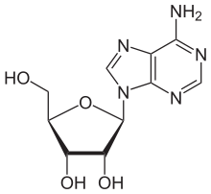
Molecular Formula: C₁₀H₁₃N₅O₄
Molecular Weight: 267.271g
An important component of DNA.

Chemical Name: Adenosine diphosphate (ADP)
Structural Formula:
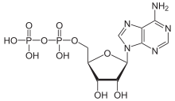

Molecular Formula: C₁₀H₁₅N₅O₁₀P₂
Molecular Weight: 427.201g
A compound that is converted to ATP for energy storage.

Chemical Name: Adenosine monophosphate (AMP)
Structural Formula:
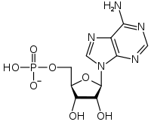
Molecular Formula: C₁₀H₁₄N₅O₇P
Molecular Weight: 347.22g
A compound found in animal cells and convertible to ADP and ATP for energy storage.

Chemical Name: Adenosine triphosphate (ATP)
Structural Formula:
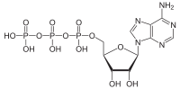
Molecular Formula: C₁₀H₁₆N₅O₁₃P₃
Molecular Weight: 507.18g
A compound used to transport energy to cells.

Chemical Name: Adonitol (Ribotol)
Structural Formula:
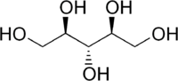
Molecular Formula: C₅H₁₂O₅
Molecular Weight: 152.15g
Is found in some plants, and contributes to the structure of riboflavin.

Chemical Name: Aflatoxin
Structural Formula:
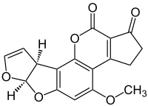
Molecular Formula:
Molecular Weight:
A substance produced by molds that grow on grain and nuts that has been linked to the formation of cancer.

Chemical Name: Alamethicin
Structural Formula:
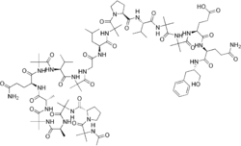
Molecular Formula: C₉₂H₁₅₀N₂₂O₂₅
Molecular Weight: 1964.31 g
An antibiotic produced by fungi.

Chemical Name: Alanine
Structural Formula:
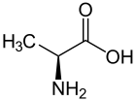
Molecular Formula: C₃H₇NO₂
Molecular Weight: 89.09g
A nonessential amino acid that is found in a wide variety of foods such as meat, eggs, whole grain, whey, and nuts.

Chemical Name: Alantoin
Structural Formula:
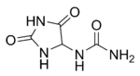
Molecular Formula: C₄H₆N₄O₃
Molecular Weight: 158.12 g
A substance used to reduce skin irritation and to quicken wound healing.

Chemical Name: Alpha Linolenic Acid
Structural Formula:

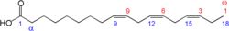
Molecular Formula: C₁₈H₃₀O₂
Molecular Weight: 278.43 g
A polyunsaturated fatty acid commonly found in vegetable products and used to prevent heart attacks, lower high blood pressure and cholesterol, and reverse atherosclerosis.

Chemical Name: Alpha Lipoic Acid
Structural Formula:

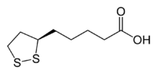
Molecular Formula: C₈H₁₄O₂S₂
Molecular Weight: 206.33 g
An antioxidant soluble in both water and fatty tissues that is used for detoxification of the body, fighting inflammation, and providing energy to the body.

Chemical Name: Arabinose
Structural Formula:
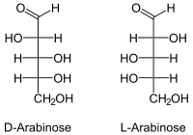
Molecular Formula: C₅H₁₀O₅
Molecular Weight: 150.13 g
A sugar obtained from plants, especially cedars and pines.

Chemical Name: Arachidonic Acid
Structural Formula:

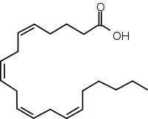
Molecular Formula: C₂₀H₃₂O₂
Molecular Weight: 304.47 g
An unsaturated fatty acid that is found in animal fat and essential for human nutrition.

Chemical Name: Arginine (L)
Structural Formula:
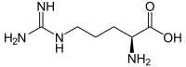
Molecular Formula: C₆H₁₄N₄O₂
Molecular Weight: 174.2 g
A nonessential amino acid involved in waste elimination and in the synthesis of creatine. Arginine is used to aid those with heart or blood vessel conditions, chest pain, and high blood pressure.

Chemical Name: Ascorbic Acid (Vitamin C)
Structural Formula:
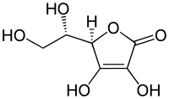
Molecular Formula: C₆H₈O₆
Molecular Weight: 76.12 g mol⁻¹
A vitamin found in citrus fruits, tomatoes, potatoes, and leafy green vegetables.

Chemical Name: Asparagine
Structural Formula:
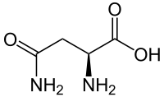
Molecular Formula: C₄H₈N₂O₃
Molecular Weight: 132.12 g mol⁻¹
A common nonessential amino acid needed by the nervous system.

Chemical Name: Aspartic Acid
Structural Formula:
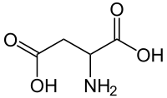
Molecular Formula: C₄H₇NO₄
Molecular Weight: 133.1 g
Also called asparaginic acid, a non-essential amino acid that plays a role in hormone production and contributes to the normal function of the nervous system. Aspartic acid is found in legumes, many nuts, flaxseed, beef, salmon, and shrimp.

Chemical Name: Astaxanthin
Structural Formula:
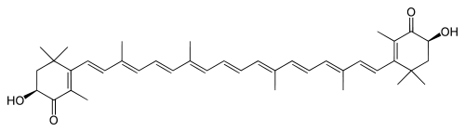
Molecular Formula: C₄₀H₅₂O₄
Molecular Weight: 596.84 g mol⁻¹
A carotenoid found in yeast, salmon, trout, krill, shrimp, crayfish, and other crustaceans.

Chemical Name: Asymmetric dimethylarginine
Structural Formula:
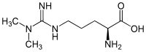
Molecular Formula: C₈H₁₈N₄O₂
Molecular Weight: 202.25 g
A naturally occurring substance in blood plasma and is the by product of protein processes in all human cells. High levels are associated with greater heart risks.

Chemical Name: Benzylaminopurine (BAP)
Structural Formula:
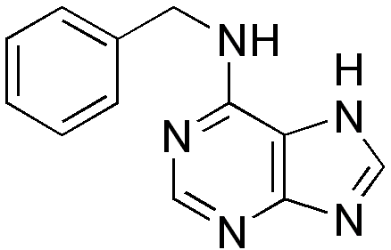
Molecular Formula: C₁₂H₁₁N₅
Molecular Weight: 225.25 g mol⁻¹
BAP promotes plant growth and stimulating fruit richness by increasing cell division.

Chemical Name: Berberine
Structural Formula:
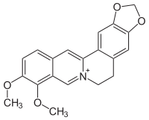
Molecular Formula: C₂₀H₁₈NO₄+
Molecular Weight: 336.36122 g
A plant alkaloid isolated from the roots and bark of several herbs, including barberry and goldenseal. Berberine containing plants are used medicinally in Ayurvedic and Chinese treatment systems. Berberine has demonstrated antimicrobial functionality and is used to reduce inflammation..

Chemical Name: Beta Carotene
Structural Formula:

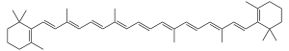
Molecular Formula: C₄₀H₅₆
Molecular Weight: 536.87 g
A strong red-orange pigment found in a variety of fruits and vegetables.

Chemical Name: Beta Glucan
Structural Formula:

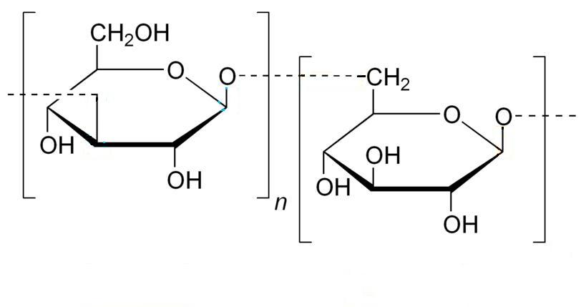
Molecular Formula:
Molecular Weight:
Beta Glucan occurs most commonly in plants, the bran of cereal grains, the cell wall of baker's yeast, certain fungi, mushrooms and bacteria.

Chemical Name: Beta Sitosterol
Structural Formula:

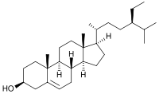
Molecular Formula: C₂₉H₅₀O
Molecular Weight: 414.71 g
A substance found in fruits, vegetables, nuts, and seeds and is used for boosting the immune system as well as heart disease and high cholesterol. Some men use it for enlarged prostate and some women use it for symptoms of menopause.

Chemical Name: Bilirubin
Structural Formula:
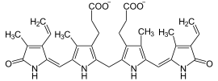

Molecular Formula: C₃₃H₃₆N₄O₆
Molecular Weight: 584.66 g
Elevated levels of this compound indicate possible diseases.

Chemical Name: Biotin
Structural Formula:
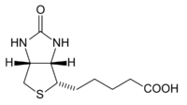
Molecular Formula: C₁₀H₁₆N₂O₃S
Molecular Weight: 244.31 g
A B-complex vitamin necessary for cell growth and the metabolism of fats and amino acids.

Chemical Name: Cadaverine
Structural Formula:
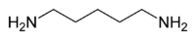
Molecular Formula: C₅H₁₄N₂
Molecular Weight: 102.178g
A mildly toxic, foul smelling compound formed during improper digestion and decay of animal tissue.

Chemical Name: Caffeine
Structural Formula:
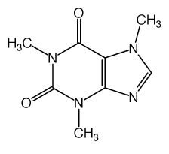
Molecular Formula: C₈H₁₀N₄O₂
Molecular Weight: 194.19g
A bitter white substance in tea and coffee which is toxic at high doses.

Chemical Name: Camphor
Structural Formula:
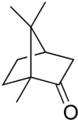
Molecular Formula: C₁₀H₁₆O
Molecular Weight: 152.23 g
A naturally occurring substance obtained from the wood or leaves of the camphor tree and used as an external treatment of mild pain and itching.

Chemical Name: Caprilyic Acid
Structural Formula:

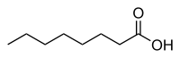
Molecular Formula: C₈H₁₆O₂
Molecular Weight: 144.21 g
A fatty acid also referred to as octanoic acid and used as an antifungal remedy.

Chemical Name: Capsaicin
Structural Formula:
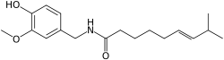
Molecular Formula: C₁₈H₂₇NO₃
Molecular Weight: 305.41 g
A colorless, pungent compound that is derived from chili peppers and is a strong irritant to skin and mucous membranes.

Chemical Name: Carbon tetrachloride
Structural Formula:
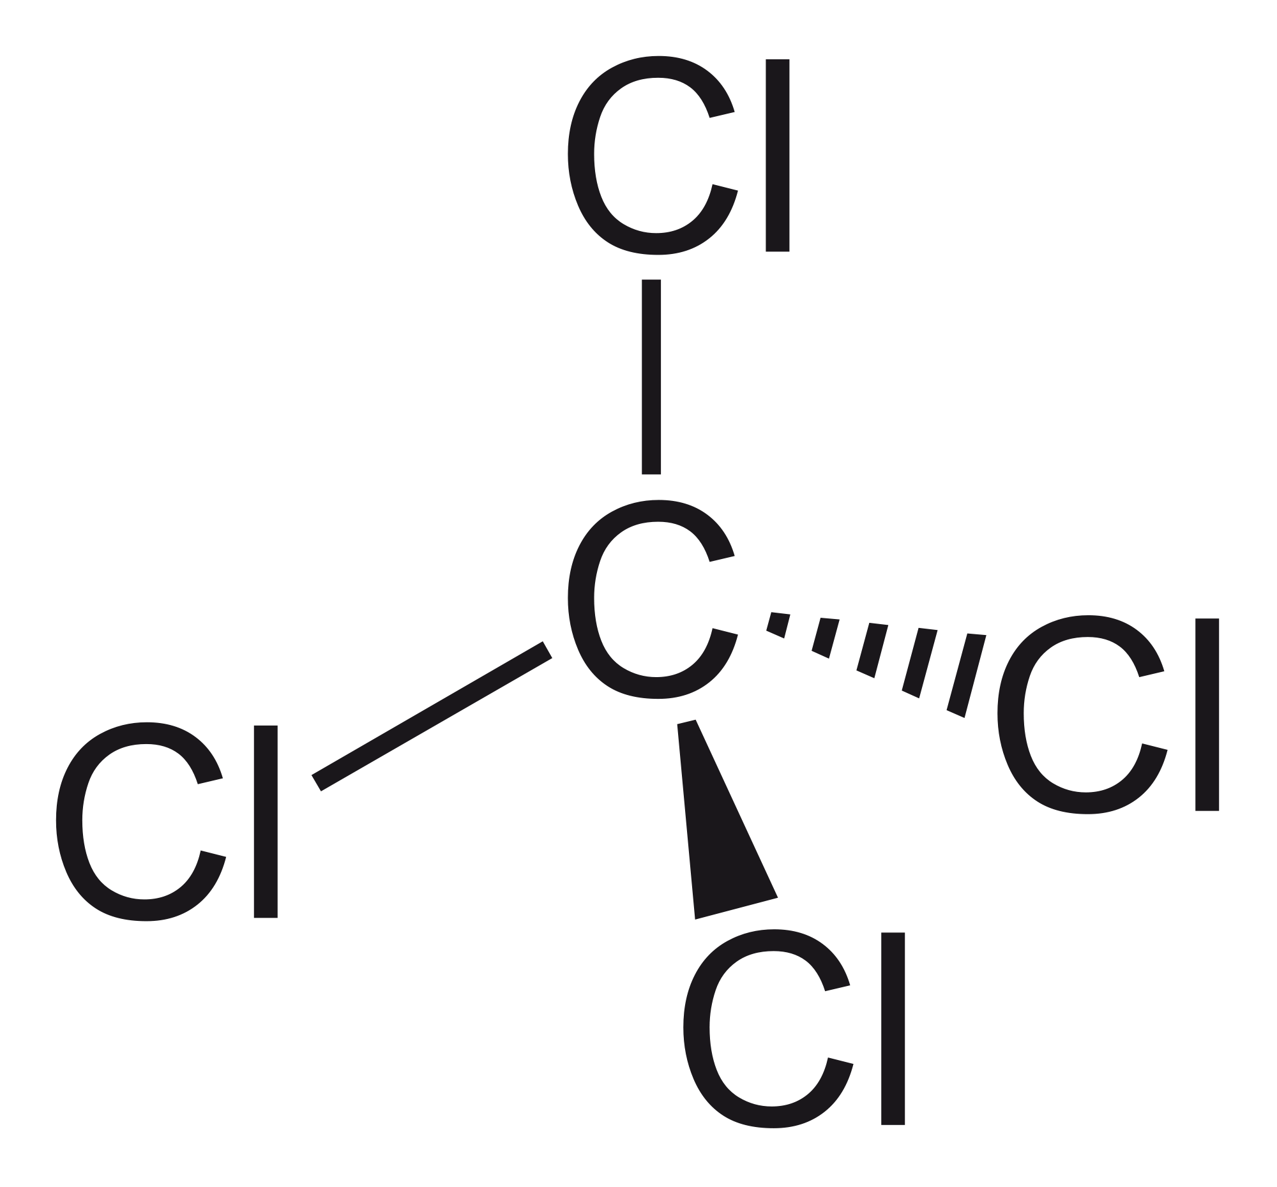
Molecular Formula: CCl₄
Molecular Weight: 53.82 g mol⁻¹
It was formerly widely used in fire extinguishers, as a precursor to refrigerants, and as a cleaning agent.

Chemical Name: Carnitine
Structural Formula:
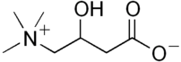
Molecular Formula: C₇H₁₅NO₃
Molecular Weight: 161.199 g
A gamma amino (the amino group is attached to the third carbon from the CO2H group) acid, found in the liver and in skeletal muscle, and is used in heart conditions.

Chemical Name: Catechin
Structural Formula:

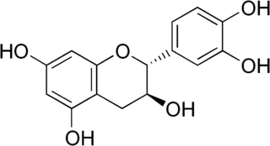
Molecular Formula: C₁₅H₁₄O₆
Molecular Weight: 290.26 g/mol
A plant material with strong antioxidant properties found in chocolate, acai oil, peaches, and vinegar.

Chemical Name: Catechin gallate
Structural Formula:
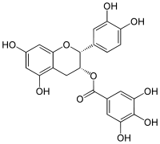
Molecular Formula: C₂₂H₁₈O₁₀
Molecular Weight: 442.37 g/mol
A strong antioxidant found in green tea, buckwheat, and grapes.

Chemical Name: Chloroform
Structural Formula:
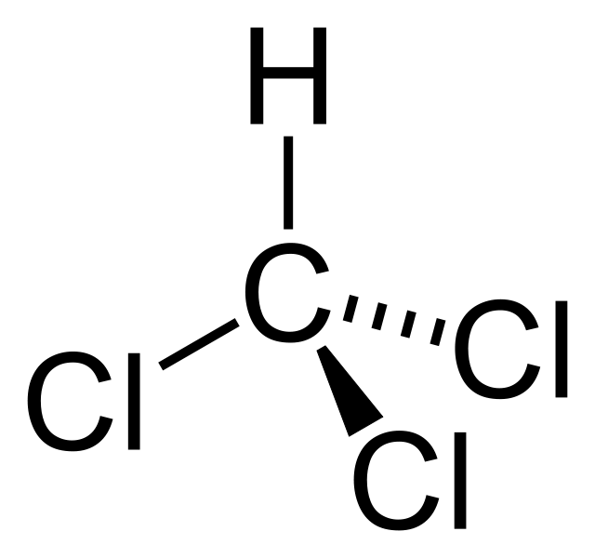
Molecular Formula: CHCl₃
Molecular Weight: 119.38 g mol⁻¹
A solvent that was widely used to replace ether as an anesthetic, but found to cause heart and liver problems.
Chemical Name: Cholesterol
Structural Formula:
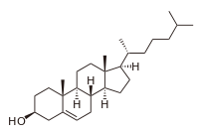
Molecular Formula: C₂₇H₄₆O
Molecular Weight: 386.65 g
A fatty compound in all animal tissues, blood, and animal fats.

Chemical Name: Choline
Structural Formula:

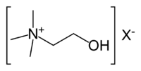
Molecular Formula: C5 H14 N O
Molecular Weight: 104.17080g
An essential nutrient that must be consumed in order for the body to remain healthy and aids in memory preservation.

Chemical Name: Chromium Picolinate
Structural Formula:
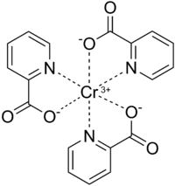
Molecular Formula: Cr(C₆H₄NO₂)₃
Molecular Weight: 418.33 g
A chemical compound used as a nutritional supplement to prevent or treat chromium deficiencies.
Chemical Name: Cinnamaldehyde
Structural Formula:
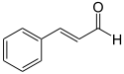
Molecular Formula: C₉H₈O
Molecular Weight: 132.16 g
An organic compound that gives cinnamon its flavor and odor.

Chemical Name: Citral (Lemonal)
Structural Formula:
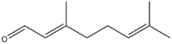
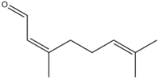
Molecular Formula: C₁₀H₁₆O
Molecular Weight: 152.24 g
A yellow liquid with a lemon odor that is derived from lemongrass oil and used in perfumes and flavoring.

Chemical Name: Citric Acid
Structural Formula:
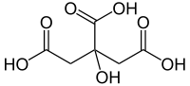
Molecular Formula: C₆H₈O₇
Molecular Weight: 192.124 g
A sour tasting acid found in a variety of plants and fruits and used as a flavoring agent.

Chemical Name: Citrinin
Structural Formula:
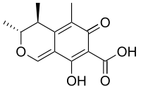
Molecular Formula: C₁₃H₁₄O₅
Molecular Weight: 250.25 g
Produced by a variety of fungi and used in the production of grain, cheese, and red pigment.

Chemical Name: Citronellal
Structural Formula:
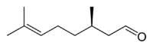
Molecular Formula: C₁₀H₁₈O
Molecular Weight: 154.25
A colorless, water soluble liquid with a lemon like odor used as flavoring in soaps, perfumes, and citronella candles.

Chemical Name: Citronellol
Structural Formula:
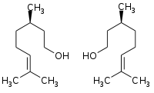
Molecular Formula: C₁₀H₂₀O
Molecular Weight: 156.27 g
A natural compound found in rose and geranium oils and is used in perfumes, insect repellants, and mite attractants and is regarded by the FDA as GRAS.

Chemical Name: Citrulline
Structural Formula:
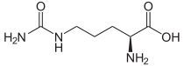
Molecular Formula: C₆H₁₃N₃O₃
Molecular Weight: 175.19 g
An alpha amino acid originally found in watermelon and is used to enhance athletic performance.

Chemical Name: Cobalamin
Structural Formula:
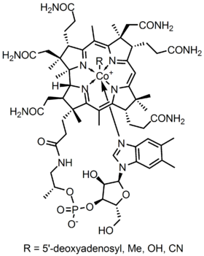
Molecular Formula: C₆₃H₈₈CoN₁₄O₁₄P
Molecular Weight: 1355.37 g
An essential nutrient responsible for healthy brain and nervous system function.

Chemical Name: CoQ10 (Coenzyme Q10), (Ubiquitone)
Structural Formula:
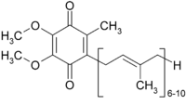
Molecular Formula: C₅₉H₉₀O₄
Molecular Weight: 863.34 g
A family of enzymes that aid in the production of energy for the human body. These have the same formula but differ in the number of isopropyl units (in the bracket above). CoQ₁₀ has ten of those units in a chain.

Chemical Name: Corticosterone
Structural Formula:
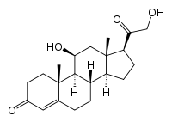
Molecular Formula: C₂₁H₃₀O₄
Molecular Weight: 346.46 g
A steroid hormone secreted by the adrenal gland that functions in the metabolism of carbohydrates and proteins.

Chemical Name: Cortisol
Structural Formula:
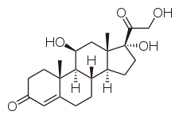
Molecular Formula: C₂₁H₃₀O₅
Molecular Weight: 362.460g
A steroid hormone released in response to stress and used to treat a variety of diseases.

Chemical Name: Creatine
Structural Formula:
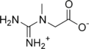
Molecular Formula: C₄H₉N₃O₂
Molecular Weight: 131.13 g
An organic acid used to help supply energy to cells within the body.

Chemical Name: Curcumin
Structural Formula:
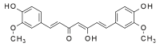
Molecular Formula: C₂₁H₂₀O₆
Molecular Weight: 368.38 g
An extract obtained from turmeric that is used as an antioxidant and anti-inflammatory agent.

Chemical Name: Cyanocobalamin
Structural Formula:
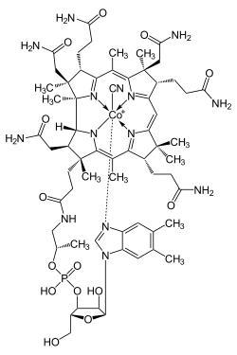
Molecular Formula: C₆₃H₈₈CoN₁₄O₁₄P
Molecular Weight: 1355.38 g
An essential nutrient responsible for promoting a healthy brain and nervous system.

Chemical Name: Cysteine
Structural Formula:
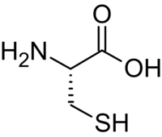
Molecular Formula: C₃H₇NO₂S
Molecular Weight: 121.16 g
A non-essential amino acid that promotes healthy hair, nails, and skin. Cysteine converts readily to cysteine when the SH groups of two cysteine molecules link together.

Chemical Name: Cytidine
Structural Formula:
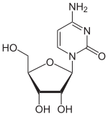
Molecular Formula: C₉H₁₃N₃O₅
Molecular Weight: 243.22 g
A substance that helps in treating the after effects of stroke.

Chemical Name: Cytosine
Structural Formula:
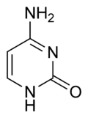
Molecular Formula: C₄H₅N₃O
Molecular Weight: 111.10 g A white crystalline substance occurring in nucleic acid a constituent of DNA and RNA.
Chemical Name: DHEA (Dehydroepiandrosterone)
Structural Formula:

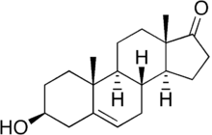
Molecular Formula: C₁₉H₂₆O₂
Molecular Weight: 288.424 g
The most abundant circulating steroid hormone in the human body.

Chemical Name: Deoxycholic acid
Structural Formula:
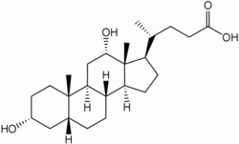
Molecular Formula: C₂₄H₄₀O₄
Molecular Weight: 392.57 g
An acid found in bile and used to prevent and dissolve gallstones.

Chemical Name: Deoxyribose (L)
Structural Formula:
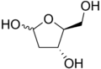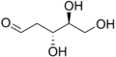
Molecular Formula: C₅H₁₀O₄
Molecular Weight: 134.13 g
A sugar obtained from DNA and used to increase energy. The two forms listed convert back and forth into each other.

Chemical Name: Dihydrolipoic Acid
Structural Formula:
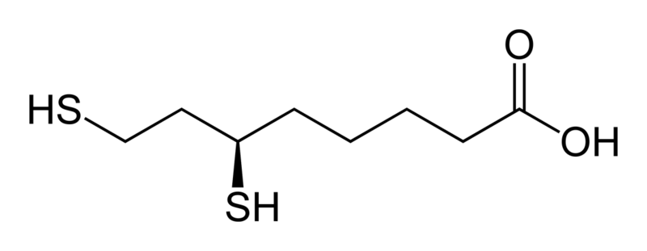
Molecular Formula: C₈H₁₆O₂S₂
Molecular Weight: 208.343
An essential coenzyme.

Chemical Name: DHA (Docosahexaenoic Acid)
Structural Formula:

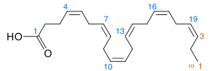
Molecular Formula: C₂₂H₃₂O₂
Molecular Weight: 328.488 g
An omega-3 fatty acid that is the primary structural component of the human brain and retina.

Chemical Name: DPA (Docosapentaenoic Acid)
Structural Formula:
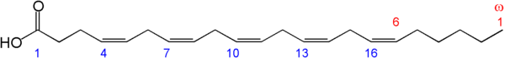

Molecular Formula:
Molecular Weight:
An omega 3 fatty acid.

Chemical Name: Dopamine
Structural Formula:
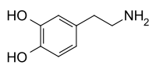
Molecular Formula: C₈H₁₁NO₂
Molecular Weight: 153.18 g
A neurotransmitter that is necessary for a healthy central nervous system.

Chemical Name: EPA (Eicosapentaenoic Acid)
Structural Formula:

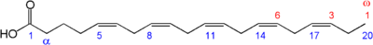
Molecular Formula: C₂₀H₃₀O₂
Molecular Weight: 302.451 g
An omega-3 fatty acid found in fish oils.

Chemical Name: Ellagic acid
Structural Formula:
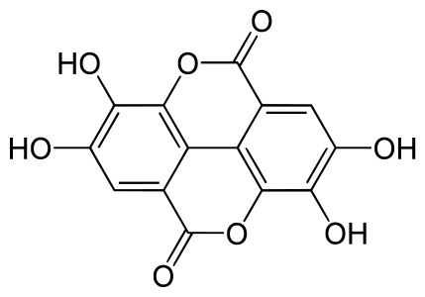
Molecular Formula: C₁₄H₆O
Molecular Weight: 302.197 g/mol
An antioxidant found in many fruits and vegetables such as blackberries, strawberries, and cranberries.

Chemical Name: Ephedrine
Structural Formula:
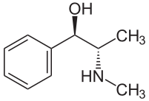
Molecular Formula: C₁₀H₁₅NO
Molecular Weight: 165.23g
A plant substance used as a stimulant, appetite suppressant, and helps mental concentration.

Chemical Name: Epicatechin
Structural Formula:
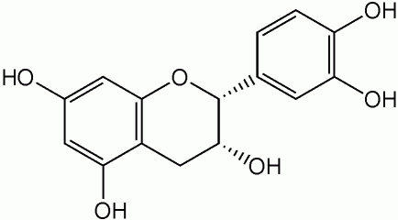
Molecular Formula: C₁₅H₁₄O₆
Molecular Weight: 290.26 g/mol
A member of the catechin family of antioxidants found in many foods.

Chemical Name: Epicatechin gallate
Structural Formula:
Molecular Formula: C₂₂H₁₈O₁₀
Molecular Weight: 442.37 g/mol
A member of the catechin family of antioxidants.

Chemical Name: Epigallocatechin gallate
Structural Formula:

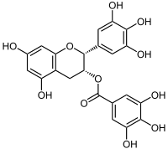
Molecular Formula: C₂₂H₁₈O₁₁
Molecular Weight: 458.37 g
An antioxidant that has therapeutic applications for multiple disorders.

Chemical Name: Epinephrine (Adrenaline)
Structural Formula:
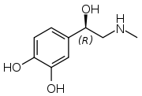

Molecular Formula: C₉H₁₃NO₃
Molecular Weight: 183.204g
A hormone secreted in response to stress, fear, or excitement.

Chemical Name: Erucic acid
Structural Formula:
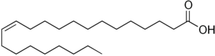
Molecular Formula: C₂₂H₄₂O₂
Molecular Weight: 338.57 g
A fatty acid in grape seed, mustard seed, and wallflower seed. Has been used to reduce heart disease rise. It has uses similar to mineral oil.

Chemical Name: Erythritol
Structural Formula:
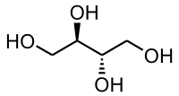
Molecular Formula: C₄H₁₀O₄
Molecular Weight: 122.1198 g
A compound extracted from algae and used to dilate the blood vessels of the heart.

Chemical Name: Estradiol
Structural Formula:
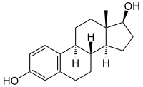
Molecular Formula: C₁₈H₂₄O₂
Molecular Weight: 272.38g
A hormone produced in the ovaries and used to treat estrogen deficiencies

Chemical Name: Eugenol
Structural Formula:
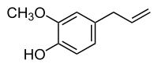
Molecular Formula: C₁₀H₁₂O₂
Molecular Weight: 164.20g
A colorless aromatic liquid made from clove oil and used as a dental analgesic and in perfume.

Chemical Name: Folic acid (Vitamin M), (Vitamin B-9)
Structural Formula:
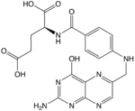
Molecular Formula: C₁₉H₁₉N₇O₆
Molecular Weight: 441.4g
Essential to numerous bodily functions as well as overall health.

Chemical Name: Formaldehyde
Structural Formula:
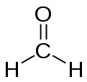
Molecular Formula: CH₂O
Molecular Weight: 30.03g
A colorless compound used as a preservative and disinfectant, which is a gas at room temperature.

Chemical Name: Formic acid
Structural Formula:
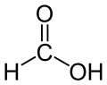
Molecular Formula: CH₂O₂
Molecular Weight: 46.03g
A colorless liquid which occurs in the venom of bee and ant stings. It is used as an antibacterial agent.

Chemical Name: Fructose
Structural Formula:
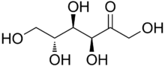
Molecular Formula: C₆H₁₂O₆
Molecular Weight: 180.16
A sugar occurring in honey and many fruits that does not raise blood sugar.

Chemical Name: Galactose
Structural Formula:
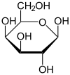
Molecular Formula: C₆H₁₂O₆
Molecular Weight: 180.156
A sugar used to improve endurance.

Chemical Name: GABA (Gamma-aminobutyric acid)
Structural Formula:
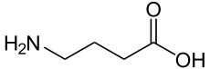
Molecular Formula: C₄H₉NO₂
Molecular Weight: 103.12
A neurotransmitter involved in brain functions. This amino acid has the amino group (NH₂) linked to the third carbon (gamma) from the acid end rather than the first one (alpha).

Chemical Name: Gamma-butrolactone
Structural Formula:
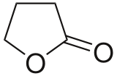
Molecular Formula: C₄H₆O₂
Molecular Weight: 86.089
A compound used to elevate growth hormones.

Chemical Name: Gamma-Linolenic Acid
Structural Formula:
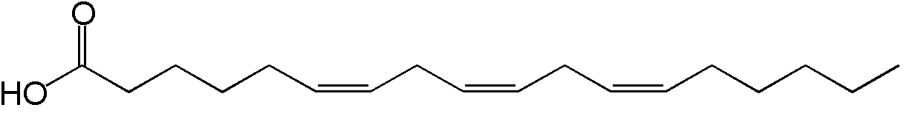
Molecular Formula: C₄H₆O₂
Molecular Weight: 86.089
Used mainly to treat inflammation and autoimmune diseases.

Chemical Name: Genistein
Structural Formula:
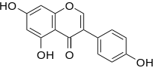
Molecular Formula: C₁₅H₁₀O₅
Molecular Weight: 270.24 g
An isoflavone found in soy and has antioxidant and anticancer properties and is also used to prevent osteoporosis, reduce cholesterol, and relieve menopausal complaints.

Chemical Name: Geraniol
Structural Formula:
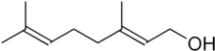
Molecular Formula: C₁₀H₁₈O
Molecular Weight: 154.25 g
A fragrant pale yellow liquid alcohol derived chiefly from the oils of geranium and citronella that is often used as a flavoring.

Chemical Name: Glucosamine
Structural Formula:
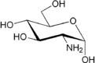
Molecular Formula: C₆H₁₃NO₅
Molecular Weight: 179.17 g
An amino sugar that is in the shell of crustaceans and cartilage.

Chemical Name: Glucose
Structural Formula:
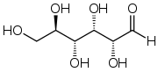
Molecular Formula: C₆H₁₂O₆
Molecular Weight: 180.16 g
A naturally occurring sugar that is used as an energy supply.

Chemical Name: Glutamic acid
Structural Formula:
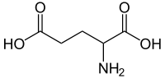
Molecular Formula: C₅H₉NO₄
Molecular Weight: 147.13 g
A non-essential amino acid that transmits nerve impulses.

Chemical Name: Glutamine
Structural Formula:
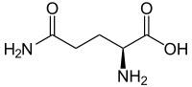
Molecular Formula: C₅H₁₀N₂O₃
Molecular Weight: 146.14g
It is non-essential amino acid occurring in plant and animal tissue and used in body building, increasing endurance, and recovery from operations. It is the most abundant free amino acid in the body.

Chemical Name: Glutathione
Structural Formula:
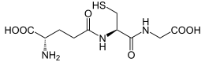
Molecular Formula: C₁₀H₁₇N₃O₆S
Molecular Weight: 307.32 g
An amino acid that is important in preventing damage to cellular components.

Chemical Name: Glycerol
Structural Formula:
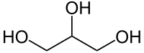
Molecular Formula: C₃H₈O₃
Molecular Weight: 92.09 g
A compound that serves as a solvent and sweetener in many foods. It combines with fatty acids to form triglycerides.

Chemical Name: Glycine
Structural Formula:
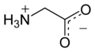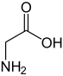
Molecular Formula: C₂H₅NO₂
Molecular Weight: 75.07 g
It is a sweet tasting amino acid commonly found in sugar beets, cane sugar, and unripe grapes. The structures above show the two forms of glycine in the body.

Chemical Name: Glycolic acid
Structural Formula:
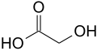
Molecular Formula: C₂H₄O₃
Molecular Weight: 76.05 g
A colorless compound found in sugar beets, cane sugar, and unripe grapes.

Chemical Name: Guanine
Structural Formula:
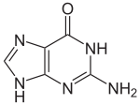
Molecular Formula: C₅H₅N₅O
Molecular Weight: 151.13 g
A component of DNA and RNA that occurs in fish scales, sugar beets, and other natural materials.

Chemical Name: Guanosine
Structural Formula:
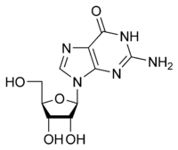
Molecular Formula: C₁₀H₁₃N₅O₅
Molecular Weight: 283.241g
A component of DNA that is composed of guanine and deoxyribose.

Chemical Name: Guanosine triphosphate
Structural Formula:
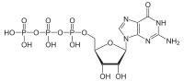
Molecular Formula: C₁₀H₁₆N₅O₁₄P₃
Molecular Weight: 523.18 g
A component of RNA and important in providing the energy needed for body chemical reactions.

Chemical Name: Hemoglobin
Structural Formula:
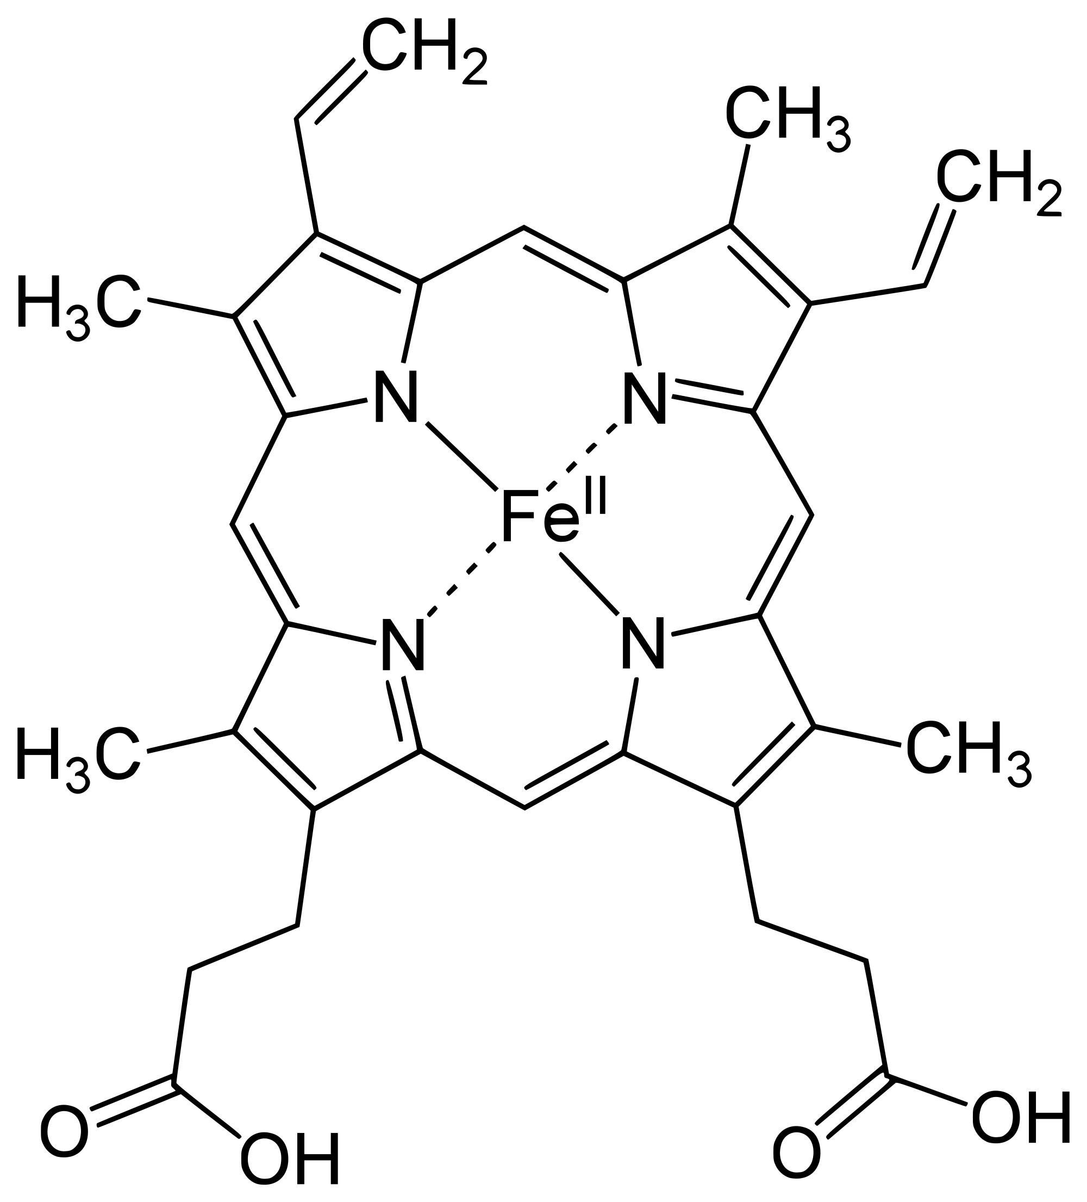
Molecular Formula:
Molecular Weight:
Hemoglobin in the blood carries oxygen from the lungs to the rest of the body, where it releases the oxygen to burn nutrients to provide energy and collects carbon dioxide to bring it back to the lungs to be removed.

Chemical Name: Hexane
Structural Formula:
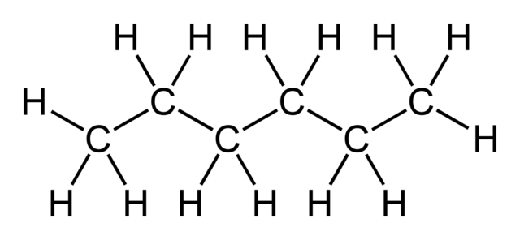
Molecular Formula: C₆H₁₄
Molecular Weight: 86.18 g mol⁻¹
Hexane is widely used to extract vegetable oils, but the commercial varieties used contain small amounts of aromatic compounds (benzene family) which can be toxic in high amounts.

Chemical Name: Histamine
Structural Formula:
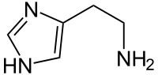
Molecular Formula: C₅H₉N₃
Molecular Weight: 111.15 g
An organic compound found widely in animals, plants, and humans and is released as part of the body’s immune response causing contraction of the airways.

Chemical Name: Histidine
Structural Formula:
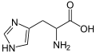
Molecular Formula: C₆H₉N₃O₂
Molecular Weight: 155.15 g
An amino acid that is essential for tissue growth and repair as well as the overall health of infants.

Chemical Name: Homocysteine
Structural Formula:
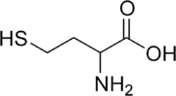
Molecular Formula: C₄H₉NO₂S
Molecular Weight: 135.18 g
A naturally occurring amino acid found in blood plasma. High levels in the blood are believed to increase the chance of heart disease, stroke, Alzheimer’s Disease, and osteoporosis.

Chemical Name: Hydrogen Peroxide
Structural Formula:
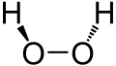
Molecular Formula: 2(HO)
Molecular Weight: 34.0147 g
A colorless liquid that is often diluted with water for use as an antiseptic.

Chemical Name: 5-Hydroxymethylcytosine
Structural Formula:
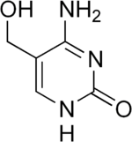
Molecular Formula: C₅H₇N₃O₂
Molecular Weight: 141.13 g
A compound found in high levels in the central nervous system..

Chemical Name: Hydroxyproline
Structural Formula:
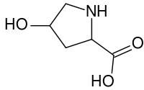
Molecular Formula: C₅H₉NO₃
Molecular Weight: 131.13g
An amino acid occurring in some proteins, especially collagen and used to treat osteoporosis, arthritis, and sports injuries.

Chemical Name: Ibuprofen
Structural Formula:
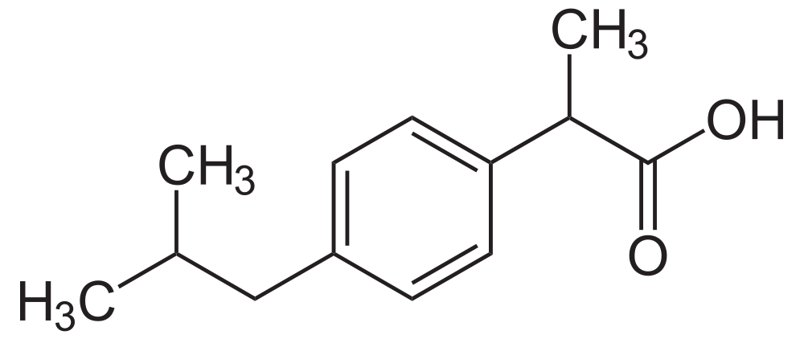
Molecular Formula: C₁₃H₁₈O₂
Molecular Weight: 206.29 g/mol
A non steroid drug used to treat arthritis.

Chemical Name: Indigo Dye
Structural Formula:
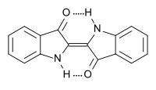
Molecular Formula: C₁₆H₁₀N₂O₂
Molecular Weight: 262.27 g
A tasteless dark blue powder from indigo plants with low toxicity which can be used to treat infections.

Chemical Name: Indole
Structural Formula:
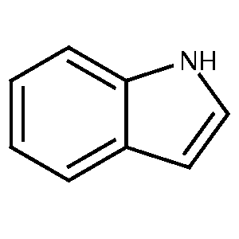
Molecular Formula: C₈H₇N
Molecular Weight: 117.15 g
A white compound that is a major construct of coal tar, but has a fragrant smell.

Chemical Name: Inosine
Structural Formula:
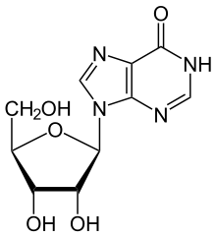
Molecular Formula: C₁₀H₁₂N₄O₅
Molecular Weight: 268.23 g
A compound derived from animal tissue that was originally used in food processing and flavoring and has been used in the treatment of cardiac disorders and is now under investigation in studies of multiple sclerosis and Parkinson’s disease.

Chemical Name: Inositol
Structural Formula:
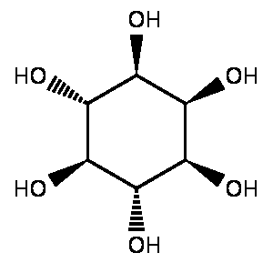
Molecular Formula: C₆H₁₂O₆
Molecular Weight: 180.16 g
A carbohydrate found in many foods, particularly fruits, that can be used for depression, autism, Alzheimer’s Disease, psoriasis, and nerve pain.

Chemical Name: Inulin
Structural Formula:
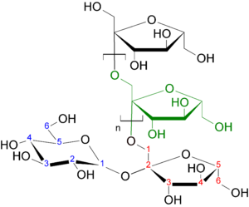
Molecular Formula: C_{6n}H_{10n+2}O_{5n+1}
Molecular Weight: Dependent on n
A dietary fiber with a bland mild sweet flavor that promotes the growth of friendly stomach bacteria.

Chemical Name: Ionone
Structural Formula:
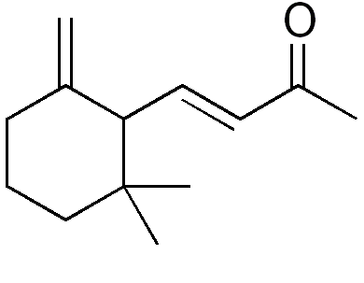
Molecular Formula: C₁₃H₂₀O
Molecular Weight: 192.30 g
A liquid mixture of two isomers with a violet-like odor that is used in perfume.

Chemical Name: Isoflavones
Structural Formula:
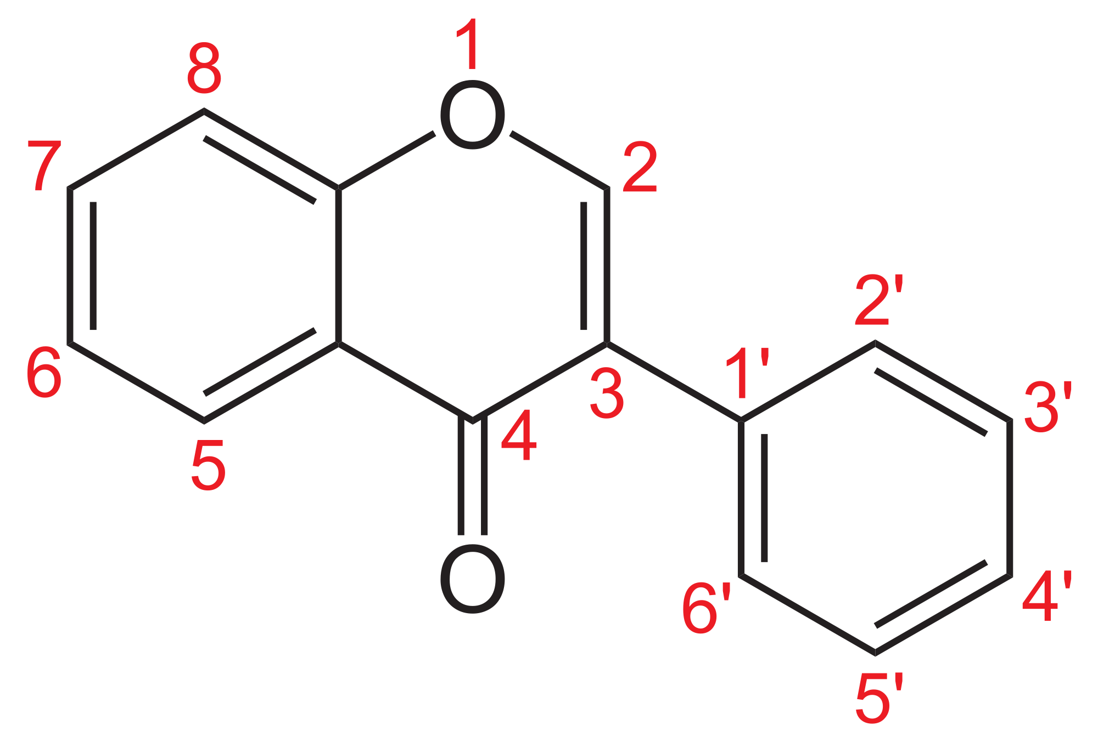
Molecular Formula:
Molecular Weight:
This is a naturally occurring family which have different functional groups attached to the numbers listed. Soy beans are the most common source in human diets.

Chemical Name: Lactic Acid
Structural Formula:

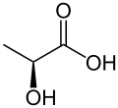
Molecular Formula: C₃H₆O₃
Molecular Weight: 90.08 g
A chemical compound that is a product of fermentation or exercise.

Chemical Name: Lauric Acid
Structural Formula:

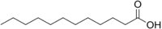
Molecular Formula: C₁₂H₂₄O₂
Molecular Weight: 200.31776g
A white, powdery saturated fatty acid that is found in human breast milk, coconut oil, palm kernel oil, and laurel oil.

Chemical Name: Linoleic Acid
Structural Formula:

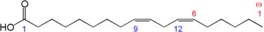
Molecular Formula: C₁₈H₃₂O₂
Molecular Weight: 280.45 g
A polyunsaturated fatty acid abundantly found in many vegetable oils with two double bonds. This comes in many forms, depending on where the double bonds are.

Chemical Name: Lutein
Structural Formula:
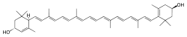
Molecular Formula: C₄₀H₅₆O₂
Molecular Weight: 568.87 g
A yellow carotenoid pigment that has been discovered in body fats, egg yolk, and green plants.

Chemical Name: Lycopene
Structural Formula:
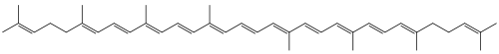
Molecular Formula: C₄₀H₅₆
Molecular Weight: 536.87 g mol⁻¹
A red pigment found chiefly in blood and the reproductive organs, from tomatoes, and palm oils and serves as an antioxidant.

Chemical Name: Lysine
Structural Formula:

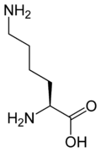
Molecular Formula: C₆H₁₄N₂O₂
Molecular Weight: 146.19 g
An essential amino acid required for optimal body growth and bone health.

Chemical Name: Malic Acid
Structural Formula:

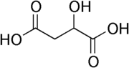
Molecular Formula: C₄H₆O₅
Molecular Weight: 134.09 g
A compound that occurs naturally in a wide variety of unripe fruit, including apples, cherries, and tomatoes and helps develop energy for the body.

Chemical Name: Malondialdehyde
Structural Formula:
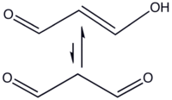
Molecular Formula: C₃H₄O₂
Molecular Weight: 72.0636 g
An organic compound used as a biomarker to measure oxidative stress.

Chemical Name: Maltose
Structural Formula:

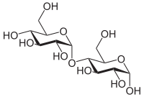
Molecular Formula: C₁₂H₂₂O₁₁
Molecular Weight: 342.30 g
A sugar that helps increase energy and improve performance.

Chemical Name: Melatonin
Structural Formula:

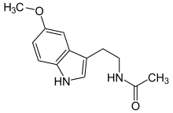
Molecular Formula: C₁₃H₁₆N₂O₂
Molecular Weight: 2.278 g
A hormone that plays a role in biological rhythms such as sleep and reproduction.

Chemical Name: Menaquinone (Vitamin K-2)
Chemical Structure:
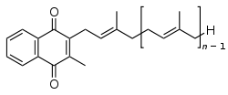
This term refers to a chemical family with a varying number of isoprenoid units in the n-1 side chain. Its use reduces bone fractures and heart disorders.

Chemical Name: Methionine
Structural Formula:

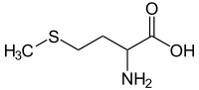
Molecular Formula: C₅H₁₁NO₂S
Molecular Weight: 149.21 g
An essential amino acid containing sulfur that helps the body process and eliminate fat.

Chemical Name: Methylcobalamin
Structural Formula:
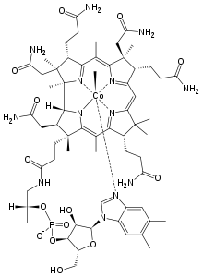
Molecular Formula: C₆₃H₉₁CoN₁₃O₁₄P
Molecular Weight: 1344.40 g
A substance similar to Vitamin B12 used to treat disorders of the nervous system.

Chemical Name: Niacin (B3, Nicotinic Acid)
Structural Formula:

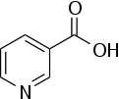
Molecular Formula: C₆NH₅O₂
Molecular Weight: 123.1094 g
An organic compound that promotes heart health and increases blood flow. Doses over 100 mg may cause a temporary itchy reddening of the skin.
Chemical Name: Nitric Oxide
Structural Formula:
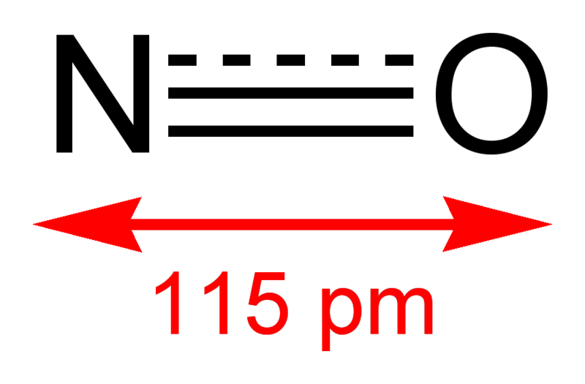
Molecular Formula: NO
Molecular Weight: 30.01 g mol⁻¹
A gas which aids in the transmission of nerve impulse.

Chemical Name: Norepinephrine
Structural Formula:

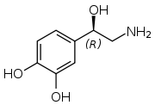
Molecular Formula: C₈H₁₁NO₃
Molecular Weight: 169.18 g
A hormone and neurotransmitter than helps increases in blood pressure, heart rate, and glucose levels.

Chemical Name: Orcinol
Structural Formula:

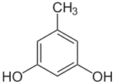
Molecular Formula: C₇H₈O₂
Molecular Weight: 124.13 g
A colorless crystalline solid that is found in many lichens.

Chemical Name: Ornithine
Structural Formula:

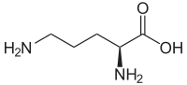
Molecular Formula: C₅H₁₂N₂O₂
Molecular Weight: 132.16 g
An amino acid important in muscular growth.

Chemical Name: Oxalic Acid
Structural Formula:

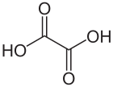
Molecular Formula: C₂H₂O₄
Molecular Weight: 90.03 g
A crystalline acid found in a number of plants such as sorrel and rhubarb. It reacts with calcium and this product is the main component of kidney stones.

Chemical Name: PABA (para-aminobenzoic acid)
Structural Formula:

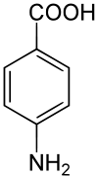
Molecular Formula: C₇H₇NO₂
Molecular Weight: 137.14 g
Part of the vitamin B complex that decreases the formation of free radicals and is used in sunscreen to protect against ultraviolet radiation.

Chemical Name: Palmitic Acid
Structural Formula:

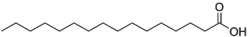
Molecular Formula: C₁₆H₃₂O₂
Molecular Weight: 256.42 g
A saturated fatty acid occuring in many natural oils and fats.

Chemical Name: Pantothenic Acid
Structural Formula:

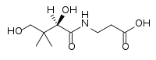
Molecular Formula: C₉H₁₇NO₅
Molecular Weight: 219.23 g
Part of the vitamin B complex found in plant and animal tissues that is used to treat skin problems, allergies, insomnia, difficulties in autism, muscular dystrophy, and diabetes.

Chemical Name: p-Coumaric Acid
Structural Formula:

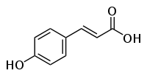
Molecular Formula: C₉H₈O₃
Molecular Weight: 164.16 g
An organic acid that has antioxidant properties and is believed to reduce the risk of stomach cancer.

Chemical Name: Phenylalanine
Structural Formula:
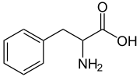
Molecular Formula: C₉H₁₁NO₂
Molecular Weight: 65.19 g
An essential amino acid needed for healthy development in infants.

Chemical Name: Phosphoric Acid
Structural Formula:

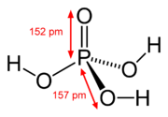
Molecular Formula: H₃PO₄
Molecular Weight: 98.00 g
A colorless solid acid used in the manufacture of soaps and fertilizers. Normally found in a combined form called phosphates.

Chemical Name: Phylloquinone (Vitamin K₁)
Structural Formula:

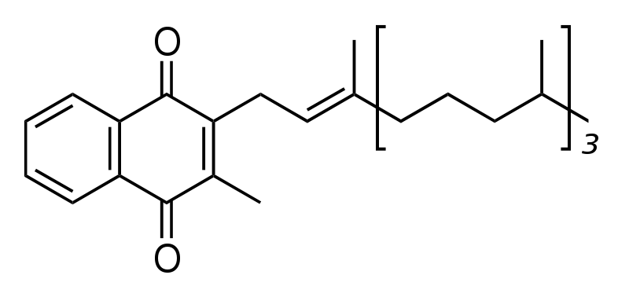
Molecular Formula: C₃₁H₄₆O₂
Molecular Weight: 450.7 g mol⁻¹
A fat soluble vitamin found in green plant leaves and has an important role in helping blood coagulate to stop bleeding from wounds.

Chemical Name: Phytic Acid (Inositol hexaphosphate)
Structural Formula:
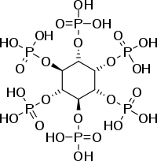
Molecular Formula: C₆H₁₈O₂₄P₆
Molecular Weight: 660.04 g
An antioxidant found within the hulls of nuts, seeds, and grains and may reduce the risk of colon cancer.

Chemical Name: Proline
Structural Formula:

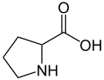
Molecular Formula: C₅H₉NO₂
Molecular Weight: 115.13 g
An amino acid that is found in many proteins and can be used to treat osteoarthritis, tissue strains, and chronic back pain.

Chemical Name: Propionic Acid
Structural Formula:

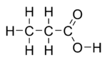
Molecular Formula: C₃H₆O₂
Molecular Weight: 74.08 g
A fatty acid found in sweat and milk products used as a mold inhibitor.

Chemical Name: Putrescine
Structural Formula:

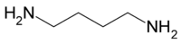
Molecular Formula: C₄H₁₂N₂
Molecular Weight: 88.15g
A colorless compound produced by decaying animal matter and toxic in high doses. At low doses it can be used to promote overall cell growth.

Chemical Name: Pyridoxine (Vitamin B₆)
Structural Formula:

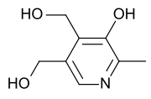
Molecular Formula: C₈H₁₁NO₃
Molecular Weight: 169.18 g
A compound that can be referred to as vitamin B6 and is linked to cardiovascular health and hormonal stability in women.

Chemical Name: Pyruvic Acid
Structural Formula:

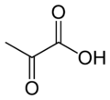
Molecular Formula: C₃H₄O₃
Molecular Weight: 88.06 g
An organic acid that supplies energy to living cells.

Chemical Name: Quercetin
Structural Formula:

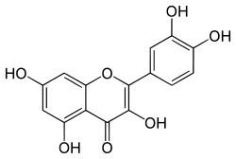
Molecular Formula: C₁₅H₁₀O₇
Molecular Weight: 302.236 g
A flavonoid found in tea with anti-inflammatory properties.

Chemical Name: Resveratrol
Structural Formula:
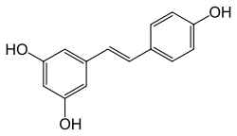
Molecular Formula: C₁₄H₁₂O₃
Molecular Weight: 228.24 g
A compound found in grapes, mulberries, peanuts, and other plant and food products that is an antioxidant. Preliminary studies show possible anti-inflammatory, blood sugar, and heart benefits.

Chemical Name: Retinol
Structural Formula:

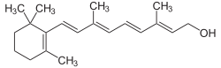
Molecular Formula: C₂₀H₃₀O
Molecular Weight: 286.45 g
One form of vitamin A that is necessary for proper vision.

Chemical Name: Riboflavin (Vitamin B2)
Structural Formula:

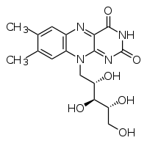
Molecular Formula: C₁₇H₂₀N₄O₆
Molecular Weight: 376.36 g
An easily absorbed nutrient that plays a key role in energy production and the metabolism of fats.

Chemical Name: Rutin
Structural Formula:

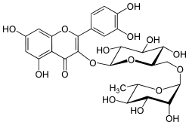
Molecular Formula: C₂₇H₃₀O₁₆
Molecular Weight: 610.517 g
A flavonoid in buckwheat, asparagus, and citrus products that helps prevent strokes and cancer, as well as lessen the symptoms of osteoarthritis.

Chemical Name: Salicin
Structural Formula:
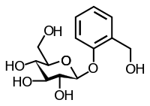
Molecular Formula: C₁₃H₁₈O₇
Molecular Weight: 286.28 g
A compound contained in white willow and poplar bark that provides anti-inflammatory effects.

Chemical Name: Selenocysteine
Structural Formula:

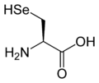
Molecular Formula: C₃H₇NO₂Se
Molecular Weight: 168.05 g
An amino acid used to help reduce the risk of cancer.

Chemical Name: Selenomethionine
Structural Formula:

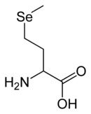
Molecular Formula: C₅H₁₁NO₂Se
Molecular Weight: 196.106 g
An amino acid that is a common natural food source of selenium and could possibly aid in the reduction of cancer.

Chemical Name: Serine
Structural Formula:

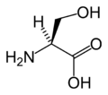
Molecular Formula: C₃H₇NO₃
Molecular Weight: 105.09 g
An amino acid that helps to control depression and anxiety.

Chemical Name: Serotonin (5-hydroxytryptamine(5-HT))
Structural Formula:
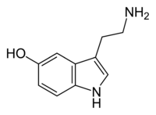
Molecular Formula: C₁₀H₁₂N₂O
Molecular Weight: 176.215 g
A neurotransmitter known as the happiness hormone that helps treat depression caused by a deficiency.

Chemical Name: Skatole
Structural Formula:
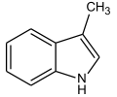
Molecular Formula: C₉H₉N
Molecular Weight: 131.17 g
A compound that is present in small amounts within many essential oils such as orange and jasmine, but harmful in large amounts.

Chemical Name: Sorbic Acid
Structural Formula:

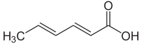
Molecular Formula: C₆H₈O₂
Molecular Weight: 112.13 g
An organic compound often used as a preservative.

Chemical Name: Squalene
Structural Formula:

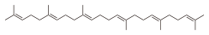
Molecular Formula: C₃₀H₅₀
Molecular Weight: 410.72 g
A compound found in the liver of sharks that may lower cholesterol, lower the risk of heart disease and cancer, and improve skin health.

Chemical Name: Stearic Acid
Structural Formula:

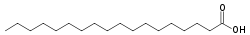
Molecular Formula: C₁₈H₃₆O₂
Molecular Weight: 284.48 g
The primary saturated fatty acid that occurs in many animal and vegetable fats and oils.

Chemical Name: Sucrose
Structural Formula:

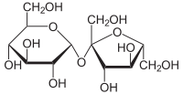
Molecular Formula: C₁₂H₂₂O₁₁
Molecular Weight: 342.30 g
A disaccharide found in many plants but extracted as ordinary sugar mainly from sugar cane and sugar beets. Widely used as a sweetener or preservative.
Chemical Name: Tartaric Acid
Structural Formula:

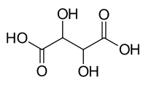
Molecular Formula: C₄H₆O₆
Molecular Weight: 150.087 g
An organic acid found in grapes and bananas that is the main acid in wine and used as an antioxidant.

Chemical Name: Taurine
Structural Formula:

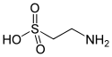
Molecular Formula: C₂H₇NO₃S
Molecular Weight: 125.15 g
An organic acid that aids in treating congestive heart failure, high blood pressure, and cystic fibrosis.

Chemical Name: Testosterone
Structural Formula:

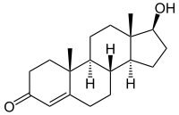
Molecular Formula: C₁₉H₂₈O₂
Molecular Weight: 288.42g
The principle male sex hormone.

Chemical Name: Thiamine
Structural Formula:

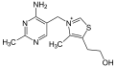
Molecular Formula: C₁₂H₁₇ClN₄OS
Molecular Weight: 300.81 g
A vitamin in the B complex found in meat and yeast and necessary for adequate carbohydrate metabolism.

Chemical Name: Threonine
Structural Formula:

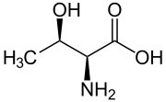
Molecular Formula: C₄H₉NO₃
Molecular Weight: 119.12 g
An essential amino acid that is often used to alleviate anxiety and boost the immune system.

Chemical Name: Thyroxine
Structural Formula:

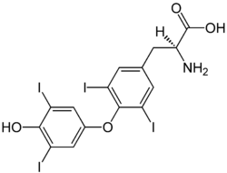
Molecular Formula: C₁₅H₁₁I₄NO₄
Molecular Weight: 776.87 g
A hormone that increases the rate of cell metabolism, regulates growth, and is used for the treatment of thyroid disorders.

Chemical Name: Tetrachloroethylene
Structural Formula:

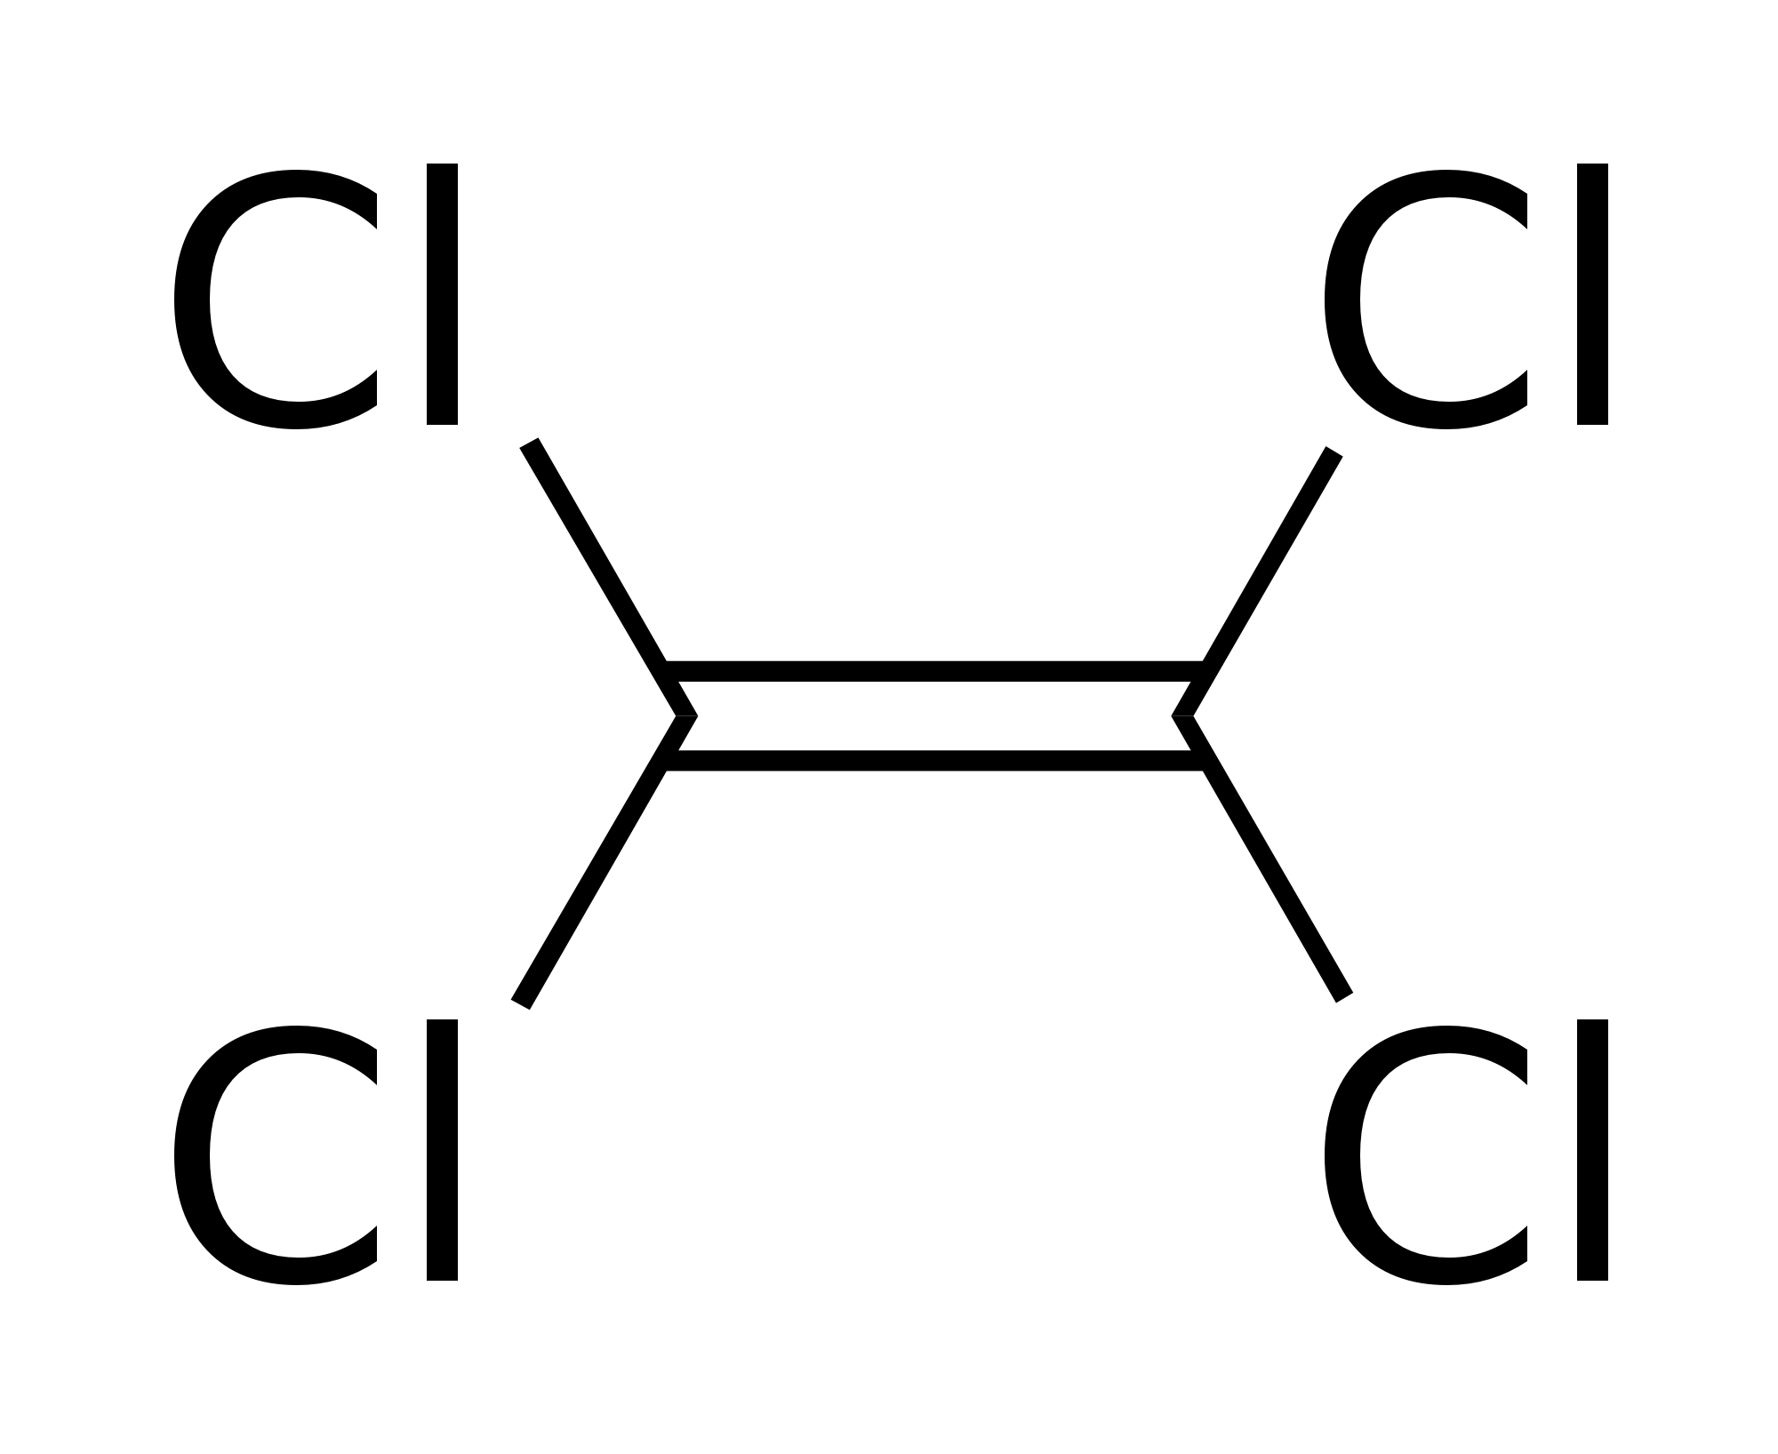
Molecular Formula: C₂Cl₄
Molecular Weight: 165.83 g mol⁻¹
A solvent widely used in dry cleaning, but was found to be a possible carcinogen

Chemical Name: Toluene
Structural Formula:

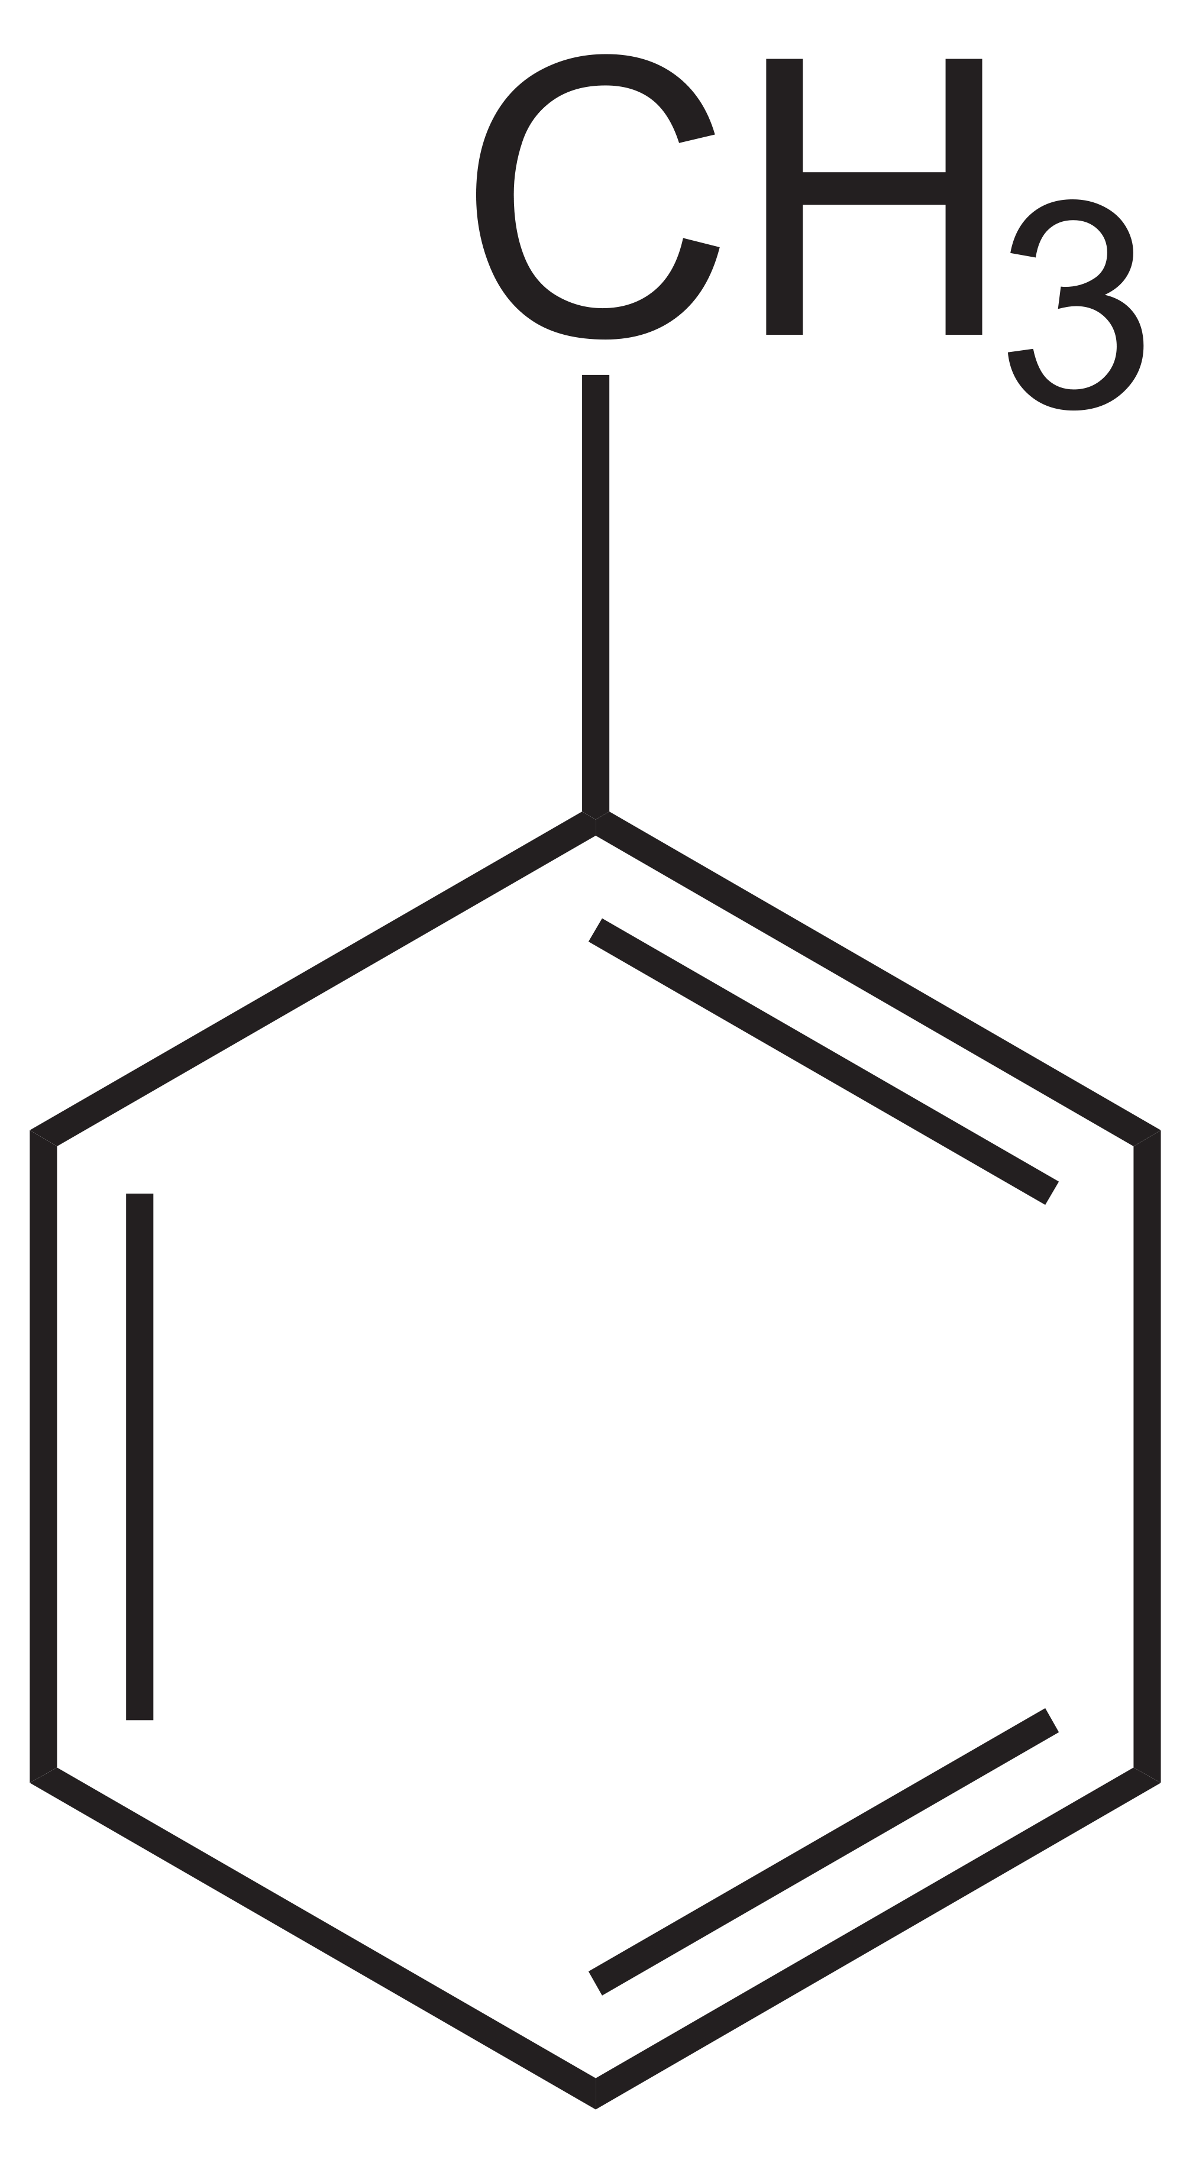
Molecular Formula: C₇H₈
Molecular Weight: 92.14 g mol⁻¹
A solvent used as a paint thinner which is less toxic than benzene.

Chemical Name: Trolox
Structural Formula:

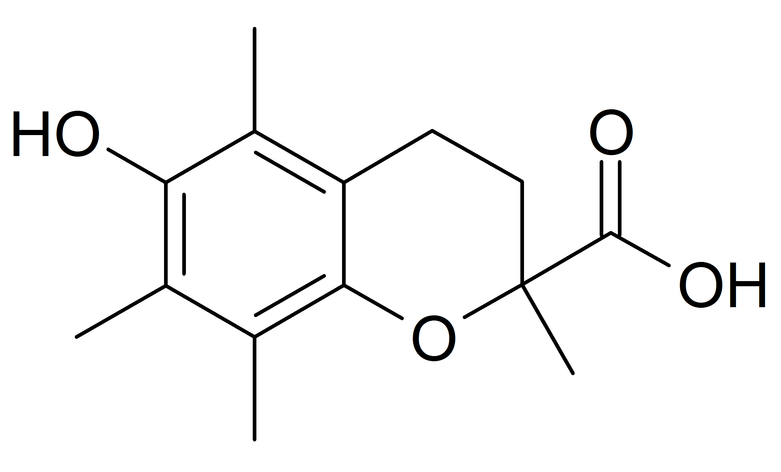
Molecular Formula: C₁₄H₁₈O₄
Molecular Weight: 250.29 g mol⁻¹
A synthetic compound similar to the tocopherols.

Chemical Name: Tyrosine
Structural Formula:

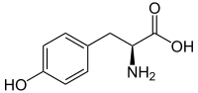
Molecular Formula: C₉H₁₁NO₃
Molecular Weight: 181.19 g mol⁻¹
An amino acid that is used as a treatment for depression, attention deficit disorder, and narcolepsy.

Chemical Name: Uracil
Structural Formula:

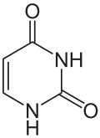
Molecular Formula: C₄H₄N₂O₂
Molecular Weight: 112.08676 g
A compound present in all living cells as part of RNA.

Chemical Name: Urea
Structural Formula:

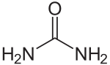
Molecular Formula: CH₄N₂O
Molecular Weight: 60.06 g
A white, water-soluble crystalline compound with often an odor of ammonia that is produced during metabolic processes and excreted in urine.

Chemical Name: Uric Acid
Structural Formula:

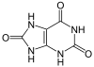
Molecular Formula: C₅H₄N₄O₃
Molecular Weight: 168.1103 g
An end product of metabolism, excreted in the urine. High body levels are associated with gout and kidney stones.

Chemical Name: Valine
Structural Formula:

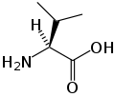
Molecular Formula: C₅H₁₁NO₂
Molecular Weight: 117.15 g
An essential amino acid that helps in growth, tissue repair, energy production and the regulation of blood sugar.

Chemical Name: Water
Structural Formula:

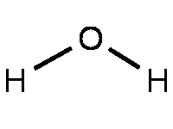
Molecular Formula: H₂O
Molecular Weight: 18.01528g
A colorless liquid required for all life.

Chemical Name: Xylene
Structural Formula:
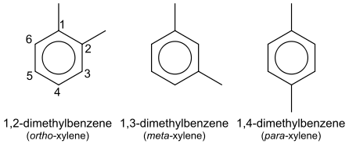
Molecular Formula: C₈H₁₀, C₆H₄(CH₃)₂ or C₆H₄C₂H₆
Molecular Weight: 106.16 g/mol
Xylene comes in 3 different shapes depending on where the methyl groups are located. It is somewhat toxic but less so than others in the benzene family like benzene and toluene

Chemical Name: Xylitol
Structural Formula:
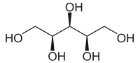
Molecular Formula: (CHOH)₃(CH₂OH)₂
Molecular Weight:
A sugar alcohol derived from xylose and often used as a sweetener in oral health products due to the fact that it does not cause tooth decay.

Chemical Name: Xylose
Structural Formula:

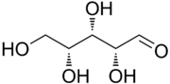
Molecular Formula: C₅H₁₀O₅
Molecular Weight: 150.13 g
A sugar used as a sweetener and does not cause tooth decay.

Chemical Name: Zeaxanthin
Structural Formula:
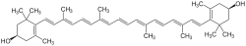
Molecular Formula: C₄₀H₅₆O₂
Molecular Weight: 568.88 g
A compound found in some fruits and vegetables that can reduce the risk of some eye diseases.

